J. angielski – 3, 4 latki
Propozycje zadań

1.Piosenka na powitanie: 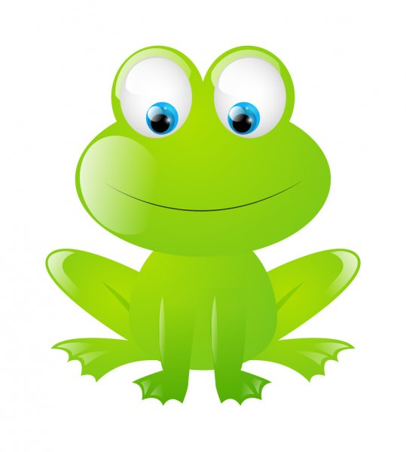

Hello to you!
Shee-bee-dee-bee-do!
Nice to see you –ooh!
Shee-bee-dee-bee-do!

2. Piosenka: Itsy bitsy spider

https://www.youtube.com/watch?v=ljHGusbX7Bk

Itsy bitsy spider climbed up the water spout
Down came the rain, and washed the spider out.
Out came the sun and dried up all the rain,
And itsy bitsy spider
Climed up the spout again.

3. Wierszyk – Wykonujemy czynności, takie jak ryba, ptak i żaba. Próbujemy naśladować ich odgłosy.

Swim, swim, swim!
Like a fish, a fish, a fish!
Glub, glub, glub!
Fly, fly, fly!
Like a bird, a bird, a bird!
Fly, fly, fly! To the tree, tree, tree!
Tweet, tweet, tweet!
Jump, jump, jump!
Like a frog, a frog, a frog!
Jump, jump, jump! In the grass, grass, grass!
Croak, croak, croak!

4. Piosenka na pożegnanie
https://www.youtube.com/watch?v=STMl4yjPpoM

